**Code:**

**build.gradle.kts(android):**

plugins {

id("com.android.application") version "8.7.0" apply false

id("org.jetbrains.kotlin.android") version "2.1.0" apply false

id("com.google.gms.google-services") version "4.4.2" apply false

}

allprojects {

repositories {

google()

mavenCentral()

}

}

val newBuildDir: Directory = rootProject.layout.buildDirectory.dir("../../build").get()

rootProject.layout.buildDirectory.value(newBuildDir)

subprojects {

val newSubprojectBuildDir: Directory = newBuildDir.dir(project.name)

project.layout.buildDirectory.value(newSubprojectBuildDir)

}

subprojects {

project.evaluationDependsOn(":app")

}

tasks.register<Delete>("clean") {

delete(rootProject.layout.buildDirectory)

}

**build.gradle.kts(app):**

plugins {

id("com.android.application")

id("kotlin-android")

id("dev.flutter.flutter-gradle-plugin")

id("com.google.gms.google-services")

}

android {

namespace = "com.example.exp6"

compileSdk = flutter.compileSdkVersion

// 🔧 Added NDK version manually

ndkVersion = "27.0.12077973"

compileOptions {

sourceCompatibility = JavaVersion.VERSION_11

targetCompatibility = JavaVersion.VERSION_11

}

kotlinOptions {

jvmTarget = JavaVersion.VERSION_11.toString()

}

defaultConfig {

applicationId = "com.example.exp6"

// 🔧 Force minSdk to 23 to support firebase_auth

minSdk = 23

targetSdk = flutter.targetSdkVersion

versionCode = flutter.versionCode

versionName = flutter.versionName

}

buildTypes {

release {

signingConfig = signingConfigs.getByName("debug")

}

}

}

flutter {

source = "../.."

}

dependencies {

// Import the Firebase BoM

implementation(platform("com.google.firebase:firebase-bom:33.12.0"))

// Firebase Authentication and Firestore

implementation("com.google.firebase:firebase-auth")

implementation("com.google.firebase:firebase-firestore")

}

**Output:**

**Login Unsuccessful:**

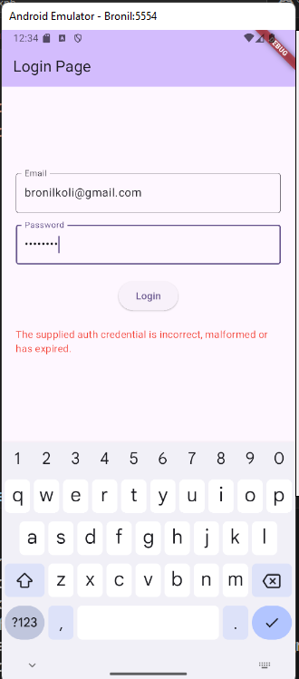

**Login Successful:**

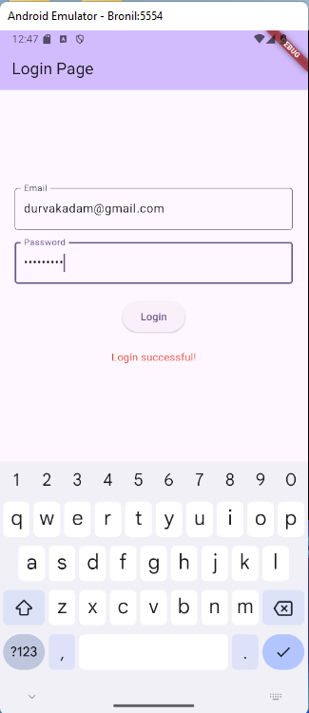

**Backend:**

